Dear Professional Colleague,
Video Presentation: Changes in Cenvat Credit Rules, 2004 vide Union Budget 2016
Effective from April 1, 2016, there are various changes made applicable under the Cenvat Credit Rules, 2004 (“the Credit Rules”), with a view to simplify and rationalize the Credit Rules. The important changes have been discussed along with availment of Cenvat credit of Service tax paid on assignment of right to use of natural resources by the Government or Local Authority or any other person.
However, there are wide ramifications entangling the extent/ availment/ utilization of Cenvat credit and reversal required in terms of Rule 6 of the Credit Rules providing for reversal of Cenvat credit in respect of inputs and input services used in manufacture of exempted goods or for provision of exempted services. Further, ‘exempted services’ as defined in Rule 2(e) of the Credit Rules now shall include an activity, which is not a ‘service’ as defined in Section 65B(44) of the Finance Act, 1994.
The Credit Rules is duly amended/ clarified by following Notifications/ Circular as on date.
Notification/ Circular No. | Particulars
Notification No. 13/2016-CE(NT)  dated March 1, 2016; | Amendment in the Credit Rules to make changes in various Rules/ Sub-rules of the Credit Rules.
Notification No. 23/2016-CE(NT) dated April 1, 2016 | Rule 6(3) of the Credit Rules, amended to provide that the assessee can pay an amount equal to 6% of value of the exempted goods and 7% of value of the exempted services subject to sum total of opening balance of Cenvat credit of input and input services available at the beginning of the period, to which the payment relates and the credit of input and input services taken during that period.  This amount initially proposed to be maximum of the total credit taken at the end of the period to which the payment relates;
Notification No. 24/2016-CE(NT) dated April 13, 2016 | Rule 4(7) of the Credit Rules, amended to provide that the Cenvat credit of Service tax paid in a financial year, on the one-time charges payable in full upfront or in instalments, for the service of assignment of the right to use any natural resource by the Government, local authority or any other person, shall be spread evenly over a period of 3 years instead of over a period of right to use.  Further, time limit of 1 year for availment of Cenvat credit on Input services is not applicable in case of services provided by Government, local authority or any other person, by way of assignment of right to use any natural resource.
Circular No. 192/02/2016-ST dated April 13, 2016 | Clarification explaining how the Cenvat credit is to be availed on Service tax paid for assignment of right to use natural resources & taxability of Governmental services.

Now, in order to provide complete understanding of the above discussed provisions and corresponding changes brought vide mentioned Notifications/ Circular, Mr. Bimal Jain has recorded a video presentation titled “Changes in Cenvat Credit Rules, 2004 vide Union Budget 2016”, for easy digest. The video also captures the important changes with practical illustrations in PPT format, facilitating ease of understanding.
You may watch the video presentation by clicking on the link below:
https://www.youtube.com/watch?v=8AfMeePYm-M
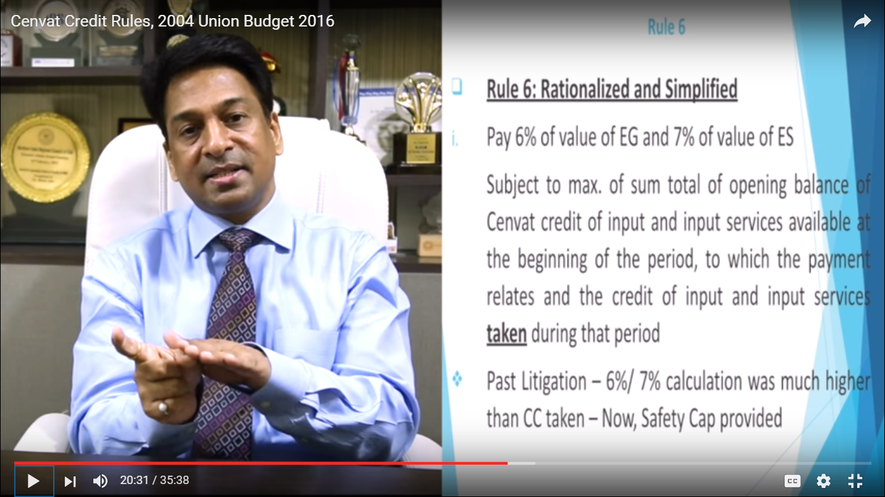

To access our earlier Video Presentation: ‘Any services’ provided by Government or Local authority to a Business Entity chargeable to ST under Reverse Charge w.e.f. April 1, 2016
Please click on the link below:
https://www.youtube.com/watch?v=AB0LpVkuoUY
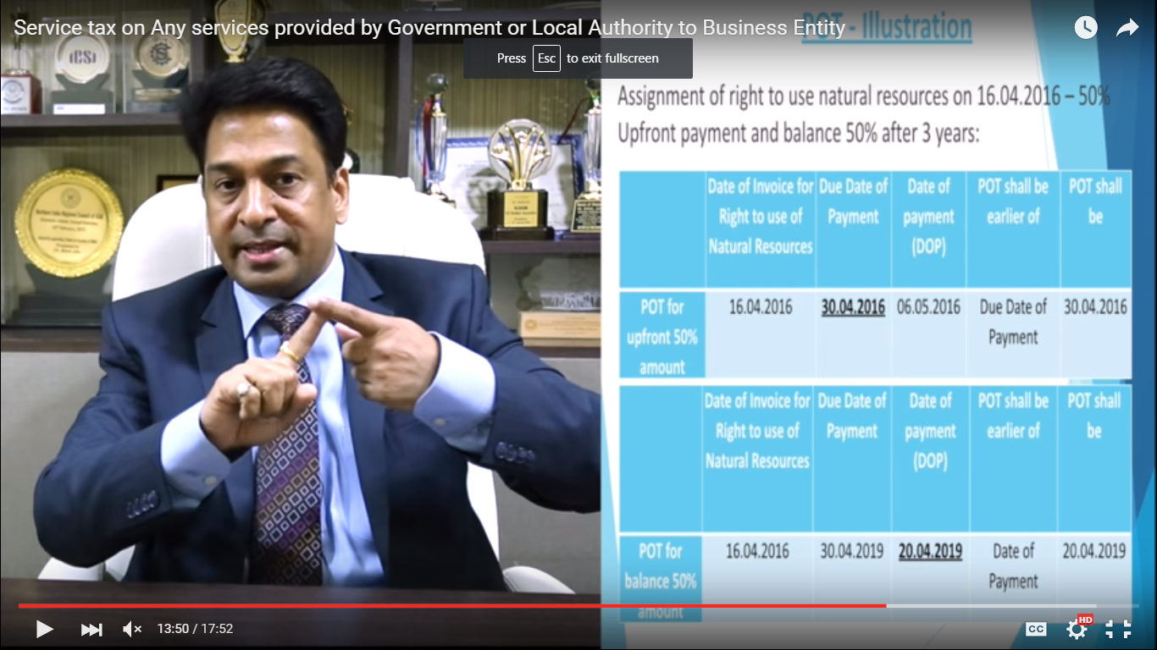

Hope the information will assist you in your Professional endeavours. In case of any query/ information, please do not hesitate to write back to us.

Thanks & Best Regards
Bimal Jain
FCA, FCS, LLB, B.Com (Hons)
Author of a book on Goods and Services Tax, titled, "GOODS AND SERVICES TAX – INTRODUCTION AND WAY FORWARD" (1st Edition)
A2Z TAXCORP LLP
Tax and Law Practitioners
Delhi:

Flat No. 34B, Ground Floor,
Pocket – 1, MayurVihar Phase-1
Delhi – 110091 (India)
Tel: +91 11 22757595/ 42427056

Allahabad:
B2-3/4-31 Sarojani Apartments
Sarojani Naidu Marg
Allahabad - 211001

Chandigarh:
H. No. 908, Sector 12-A,
Panchkula, Haryana - 134115

Email: bimaljain@hotmail.com
Web: www.a2ztaxcorp.com
LinkedIn: https://in.linkedin.com/pub/bimal-jain/14/601/4b4
Face book:facebook.com/bimal.jain.90
Twitter: https://twitter.com/JainTax
YouTube: https://www.youtube.com/channel/UCp0tT5ShjB4KHJRSlPc3t5w

We can now also be contacted at below mentioned address:
Bengaluru Office:  Adarsh Residency, Block F, 4th Floor, (F404) 47th Cross, Jayngar 8th Block,  Bengaluru, Karnataka-560070  Email: bengaluru@a2ztaxcorp.com | Kolkata Office  10 Bow Street, 2nd Floor, Near Central Metro Station, Besides Calcutta Motor Dealers Association,  Kolkata, West Bengal-700012  Email: kolkata@a2ztaxcorp.com | Dhanbad Office:  2nd Floor, Shree Laxmi Complex,  Dhanbad, Jharkhand- 826001  Email: dhanbad@a2ztaxcorp.com

Disclaimer: The contents of this document are solely for informational purpose. It does not constitute professional advice or recommendation of firm. Neither the authors nor firm and its affiliates accepts any liabilities for any loss or damage of any kind arising out of any information in this document nor for any actions taken in reliance thereon.
Readers are advised to consult the professional for understanding applicability of this newsletter in the respective scenarios. While due care has been taken in preparing this document, the existence of mistakes and omissions herein is not ruled out. No part of this document should be distributed or copied (except for personal, non-commercial use) without our written permission.

